Retail Data Warehouse ETL Pipeline
This project implements a complete ETL (Extract, Transform, Load) pipeline. It automates the process of extracting monthly sales data from CSV files, cleaning and transforming it using Python/Pandas, and loading it into a PostgreSQL Data Warehouse using a Star Schema design, orchestrated by Apache Airflow.

System Architecture
- Extract: Reads raw monthly sales data (CSV) from the /opt/airflow/dags/ directory.
- Transform: * Data cleaning and standardization.
  - Feature engineering (calculating total_revenue).
  - Data modeling (splitting data into Dimensions and Fact tables).
- Load: Upserts the final structured data into a PostgreSQL database named retail_dwh.
- Orchestration: Managed by Apache Airflow for automated scheduling and monitoring.

Data Model (Star Schema)
The warehouse is designed for high-performance analytical queries:
- Fact Table: fact_sales (Contains metrics: quantity, total revenue).
- Dimension Tables:
  - dim_customer (Customer profiles and locations).
  - dim_product (Product categories and pricing).
  - dim_date (Time attributes extracted from order dates).

Tech Stack
- Orchestration: Apache Airflow
- Processing: Python (Pandas)
- Database: PostgreSQL
- Environment: Docker & Docker-Compose
- Database Toolkit: SQLAlchemy

How to Run
- Initialize Environment: Run docker-compose up -d.
- Database Setup: Manually create a database named retail_dwh in pgAdmin.
- Data Placement: Ensure your CSV files are in the dags/ folder.
- Trigger Pipeline: Activate and trigger the Manar_Retail_Warehouse_V1 DAG from the Airflow UI.
- Verify: Use pgAdmin to query the tables under the public schema.

Troubleshooting & Problem Solving
- Path Resolution: Resolved Docker-to-Host path mapping by targeting /opt/airflow/dags/.
- Format Handling: Fixed file extension issues by converting Excel worksheets to CSV (UTF-8).
- Connection Management: Fixed "Database Not Found" errors by pre-initializing the retail_dwh schema before the ETL run.
- Container Health: Solved ERR_EMPTY_RESPONSE by performing a clean restart of the Docker stack.
Final Deliverables

The ETL Python Script (DAG.py)
This is the "Brain" of your project. It contains the Pandas code that handles:
- Extraction: Reading multiple CSV files.
- Transformation: Cleaning, merging, and calculating total_revenue.
- Loading: Establishing the connection to PostgreSQL and creating the Star Schema tables.
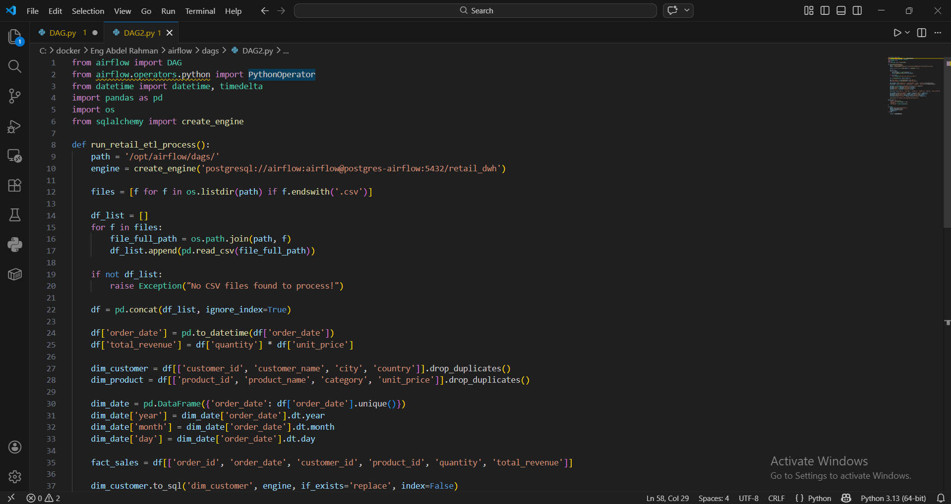
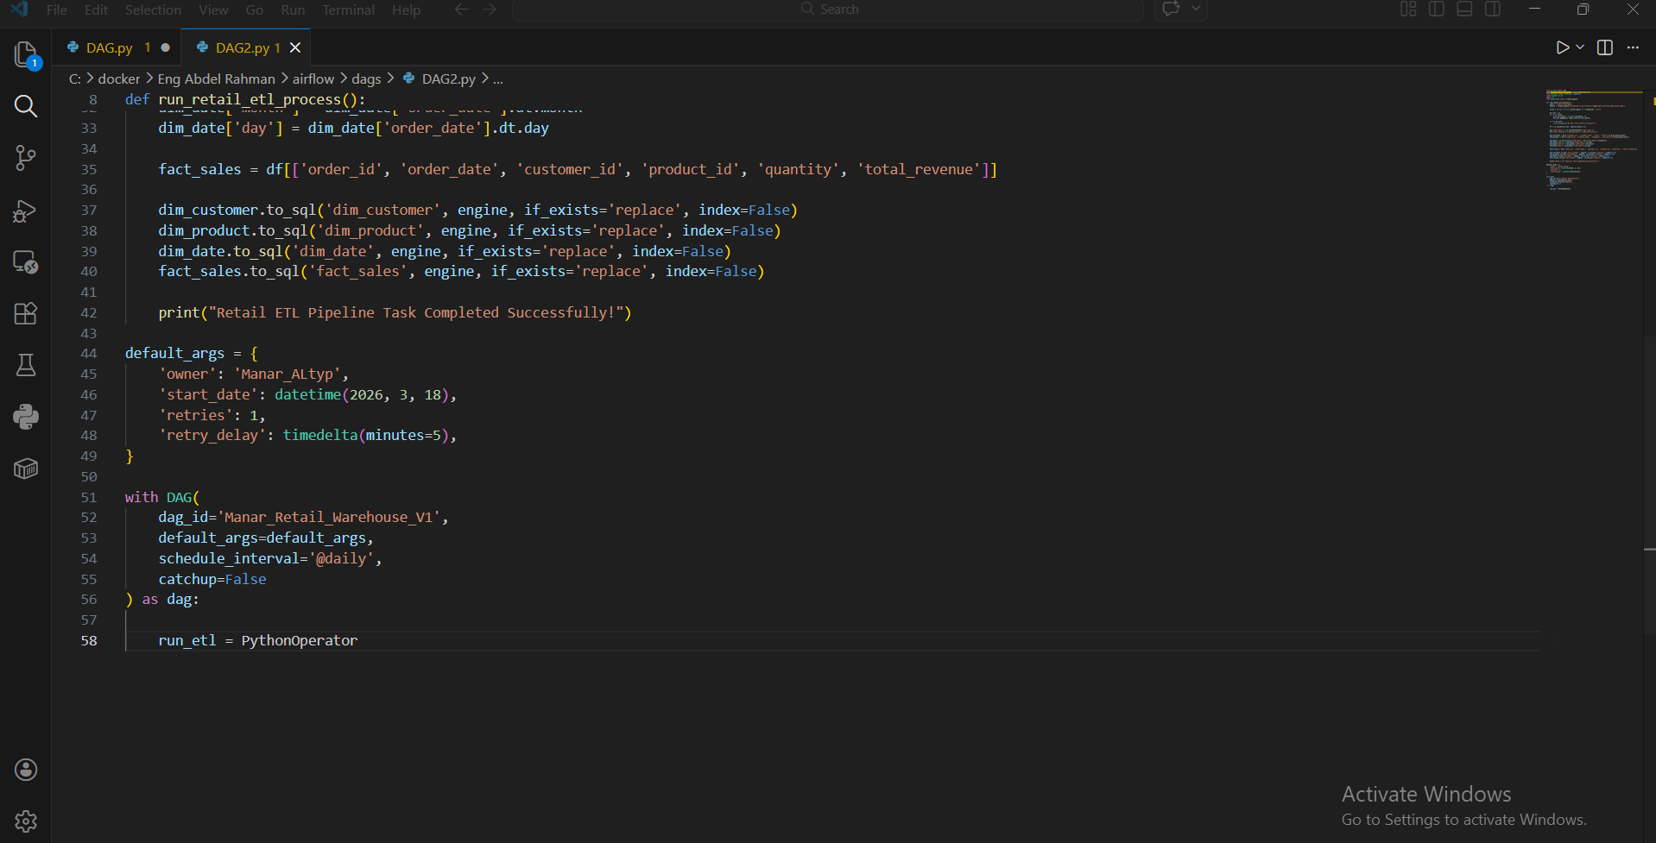

2. The Orchestration Layer (Airflow DAG)
This is the "Manager" that automates the script. The deliverable here is the DAG configuration which includes:
- Scheduling: Setting the pipeline to run @daily.
- Retries: Handling errors automatically (1 retry with 5 mins delay).
- Task Monitoring: The visual Graph View showing the green "Success" status.
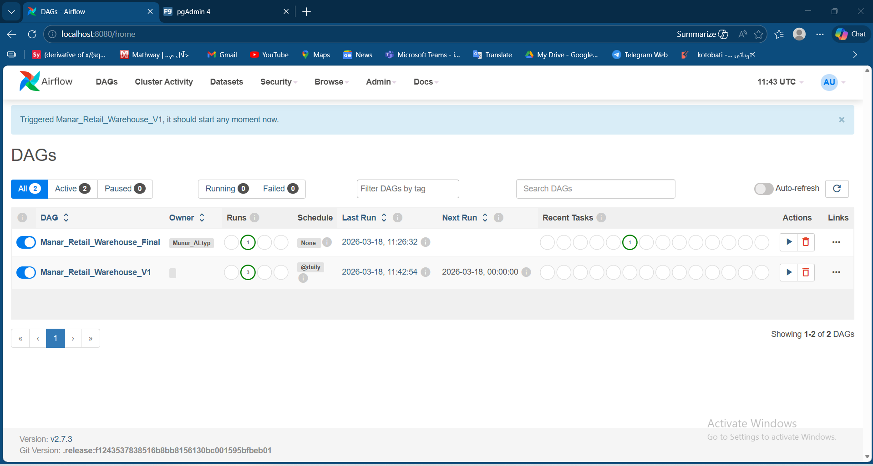

3. The Data Warehouse (PostgreSQL Tables)
The actual "Product" stored in your database. These are the tables you see in pgAdmin under the retail_dwh database:
- fact_sales: The main table with transactions and metrics.
- dim_customer, dim_product, dim_date: The supporting tables that organize your business entities.

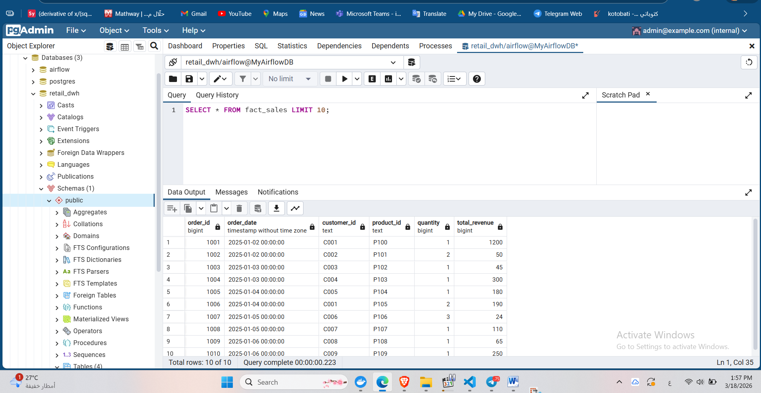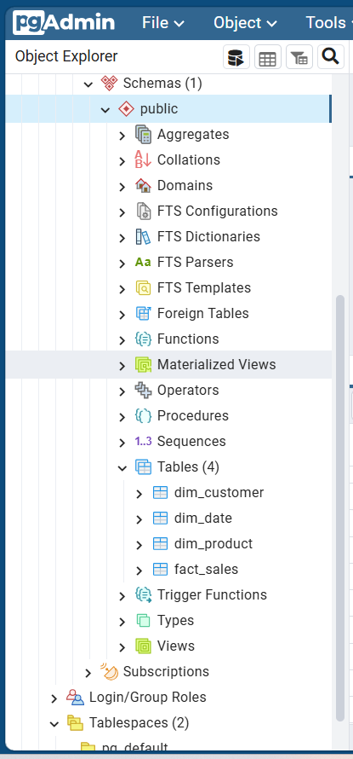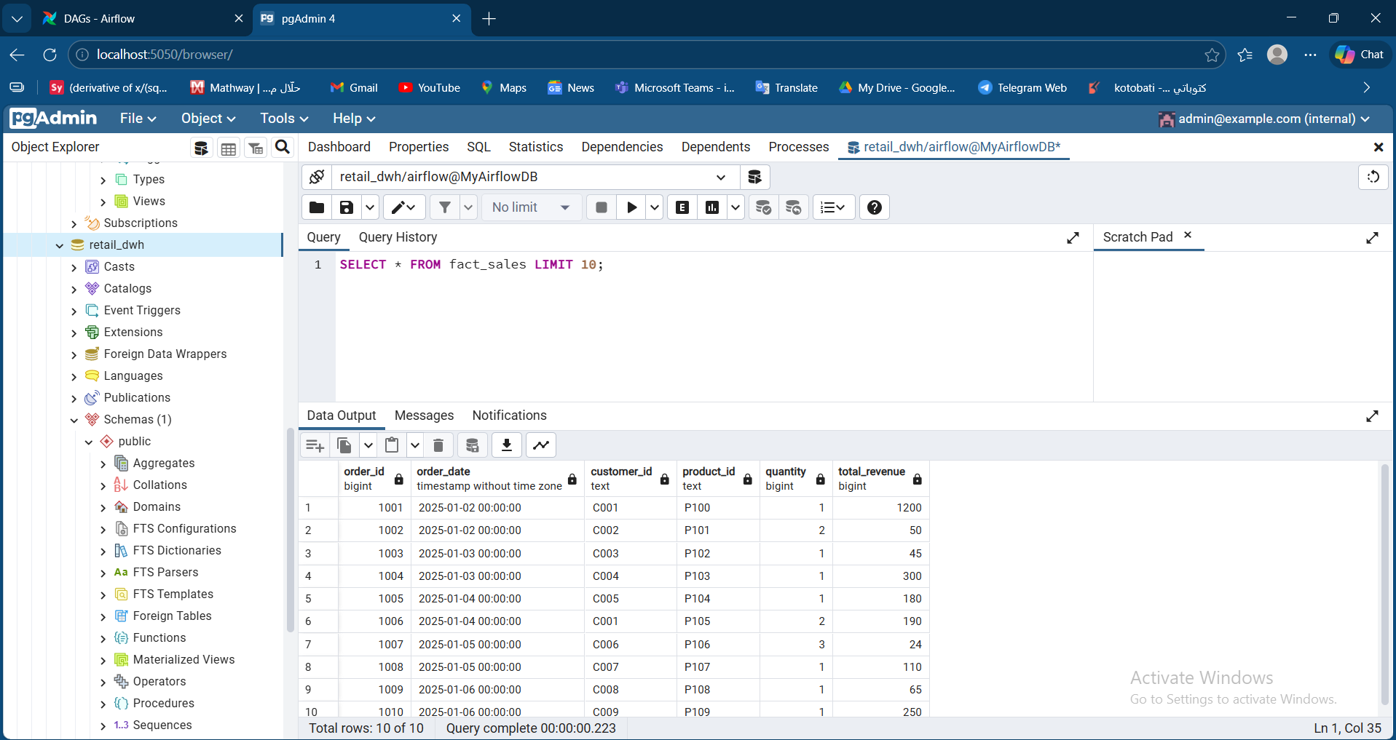

Phase 4: Data Visualization & Business Intelligence

2. Description
In this phase, I connected the PostgreSQL Data Warehouse to Power BI to create an interactive, real-time dashboard. The goal is to transform raw data into actionable business insights.

3. Key Visuals Explained
- Executive KPIs: Includes Total Revenue, Total Orders, and Average Order Value (AOV).
- Revenue Contribution: A Donut Chart showing the percentage of sales per product category.
- Sales Trends: A Line Chart visualizing monthly revenue growth.
- Performance vs. Target: A Gauge Chart measuring actual sales against a 20% growth target.
- Root Cause Analysis: An AI-powered Decomposition Tree to drill down from total revenue into categories, cities, and specific products.
- Geographic Analysis: A Map visual showing revenue distribution across different cities.

4. Technical Setup
- Connectivity: Established a secure connection to the PostgreSQL Docker container.
- Data Modeling: Implemented a Star Schema to ensure fast query performance and accurate relationships between Fact and Dimension tables.
